CSE 3241 Project Checkpoint 01 – En77es and Rela7onships

Names: Defne Ceyhan, Chaeun Hong, Yi-Ting Tsan, Maddison Chaﬃn Date: 09/26/2022

In a **NEATLY TYPED** document, provide the following:

1. Based on the requirements given in the project overview, list the enLLes to be modeled in this database. For each enLty, provide a list of associated aOributes.

**Book** (ISBN, Ltle, author, year, price, genre, quanLty)

**Publisher** (name, email)

**Customer** (username, password, email, phone number)

**Order** (order number, date, shipping address) **Refund** (item (parLal key), reason, method) ***Payment Superclass***

* + **Credit card** (number, company, cvv, name, billing address)
  + **Paypal** (username, password) Underlined aOributes are key aOributes

1. Based on the requirements given in the project overview, what are the various relaLonships between enLLes? (For example, “CUSTOMER enLLes purchase BOOK enLLes”).
   * CUSTOMER enLLes make ORDER enLLes
   * BOOK enLLes are added to ORDER enLLes
   * ORDER enLLes use PAYMENT enLLes
   * ORDER enLLes have REFUND enLLes
   * BOOK enLLes are published by PUBLISHER enLLes
2. Propose at least two addiLonal enLLes that it would be useful for this database to model beyond the scope of the project requirements. Provide a list of possible aOributes for the addiLonal enLLes and possible relaLonships they may have with each other and the rest of the enLLes in the database. Give a brief, one sentence raLonale for why adding these enLLes would be interesLng/useful to the stakeholders for this database project.

**Warehouse** (id, locaLon, capacity)

* + WAREHOUSE enLLes store BOOK enLLes
  + Fast delivery is possible based on the delivery locaLon and the nearest warehouse with the ordered books.

**Author** (id, name, bio)

* + AUTHOR enLLes write BOOK enLLes
  + One author can write many books and one book can be wriOen by mulLple authors, so this enLty can have M- to-N relaLonship between BOOK enLty.

1. Give at least four examples of some informal queries/reports that it might be useful for this database might be used to generate. Include one example for each of the addiLonal enLLes you proposed in quesLon 3 above.
2. Find quanLty lee of a speciﬁc book
3. Get a customer’s email address to contact them
4. Find closest warehouse that stores a certain book
5. For an author of one book, ﬁnd any other books wriOen by the same author
6. Suppose we want to add a new publisher to the database. How would we do that given the enLLes and relaLonships you’ve outlined above? Given your above descripLon, is it possible to add a new publisher to your database without knowing the Ltle of any books they have published? If not, revise your model to allow for publishers to be added as separate enLLes.

We have enLLes for publishers. Its aOribute contains name and contact informaLon. If we want to add a new publisher to the database, we could just add the new publisher into the database. According to the relaLonship, books must have one publisher but publishers don’t necessarily have to publish a book. So that even if we don’t know the Ltle of books they have published, we sLll can add the new publisher into the database.

1. Determine at least three other informal update operaLons and describe what enLLes would need to have aOributes altered and how they would need to be changed given your above descripLons. Include one example for each of the addiLonal enLLes you proposed in quesLon 3 above.
   * Change *price* of **book** enLty
   * Change *password* for **customer** enLty
   * Change *username* for **customer** enLty
   * Change *email* for **customer** enLty
   * Change *phone* for **customer** enLty
   * Change *email* for **publisher** enLty
   * Follow-up for quesLon 3
     + Change ***book*** *inventory* at a given **warehouse**
     + Change contact informaLon of **author**
2. Provide an ER diagram for your database. Make sure you include all of the enLLes and relaLonships you determined in the quesLons above ***INCLUDING the en;;es for ques;on 3 above***, and remember that ***EVERY*** enLty in your model needs to connect to another enLty in the model via some kind of relaLonship.

(ER diagram on next page)

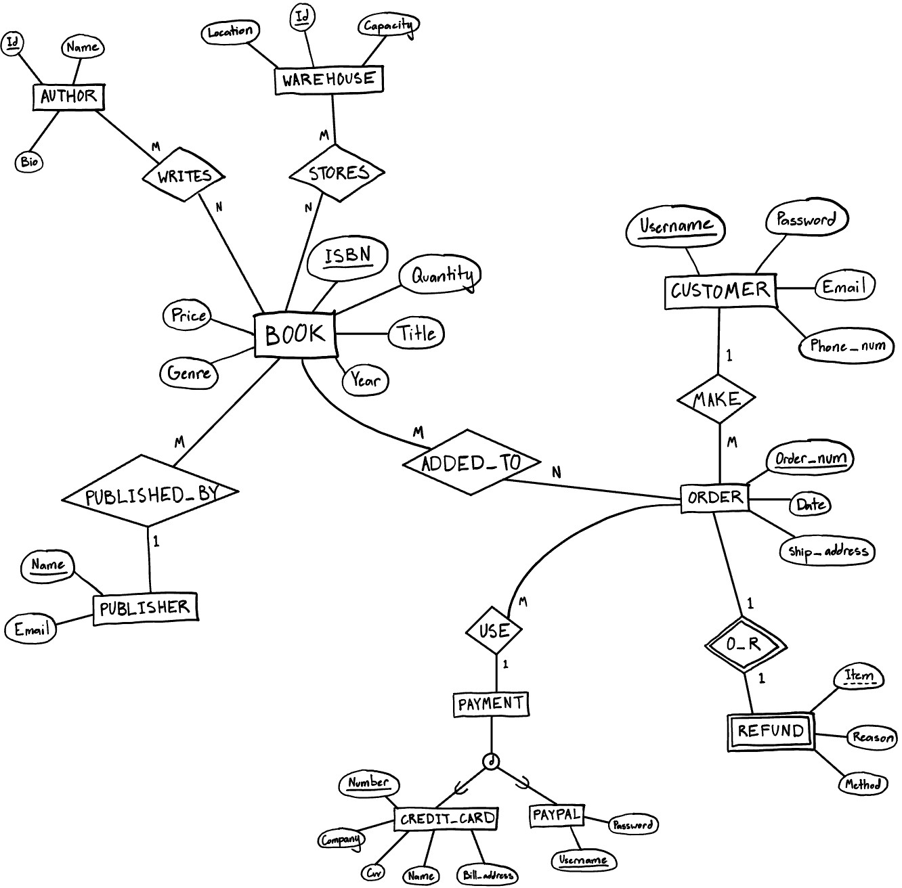

**Feedback**

Author will need to have Fname/Lname at very least, otherwise you'll searching the "name" attribute with a lot of wildcards. "Stores" relationship will need a Quantity on it, and Book will not. More than one Genre per Book? "Added_To" needs a "Quantity" as well, because what if I want to buy 3 copies of the same book on an Order?

**See Section 1 Page 1 for the new ER diagram**